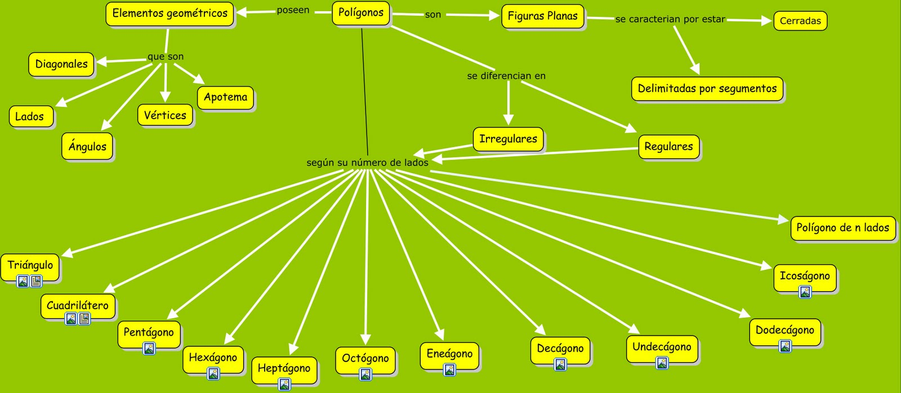

<http://2.bp.blogspot.com/_lX6bHGcU0Ws/TIudcgKaeOI/AAAAAAAAAZw/SzWZIx8pDWU/s1600/poligonos+maria+alejandra.png>

